A000-MEX-Teotihuacan-Aztec-Terracotta-100-650 CE

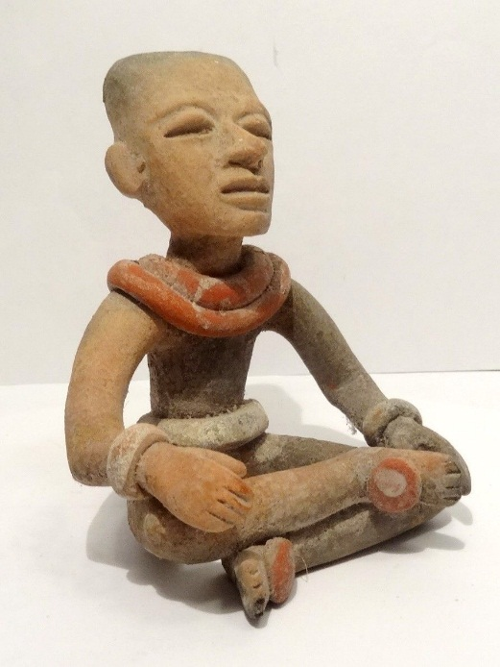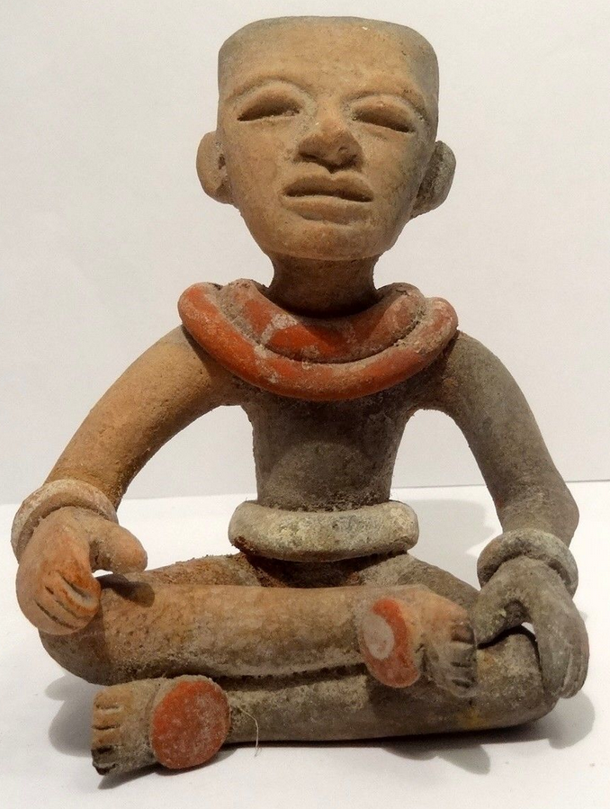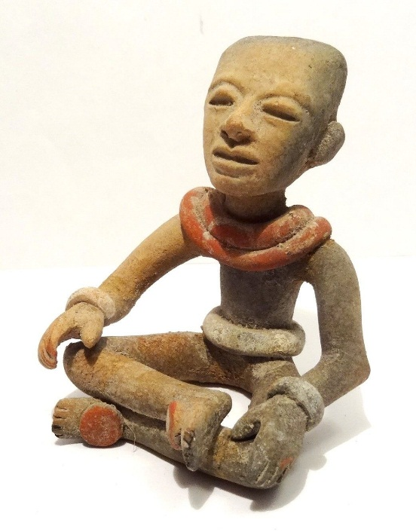 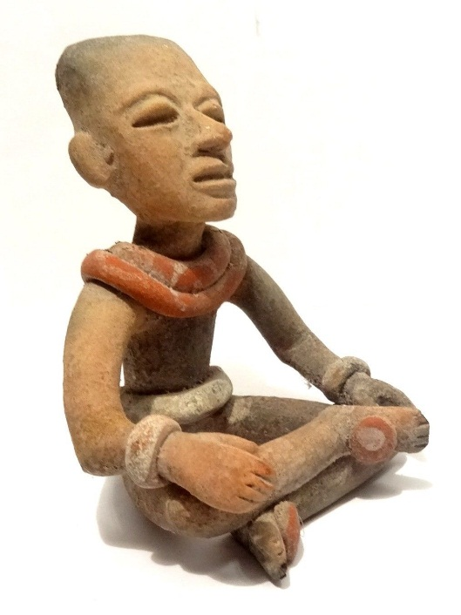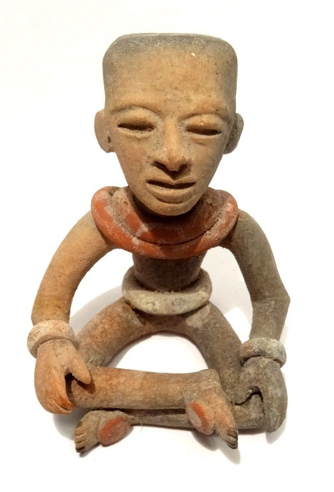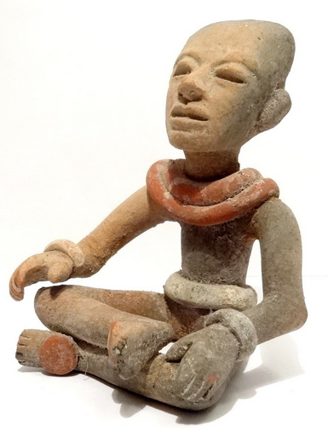

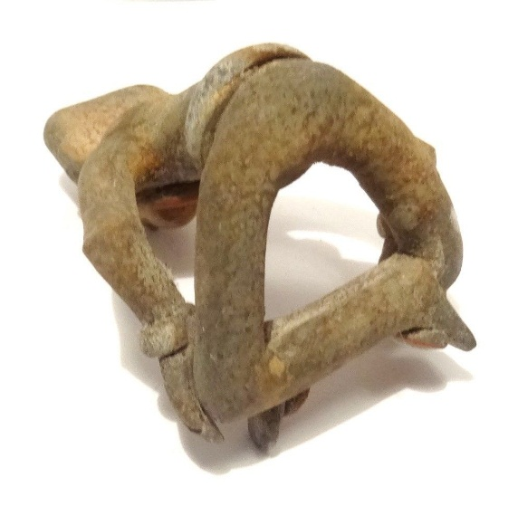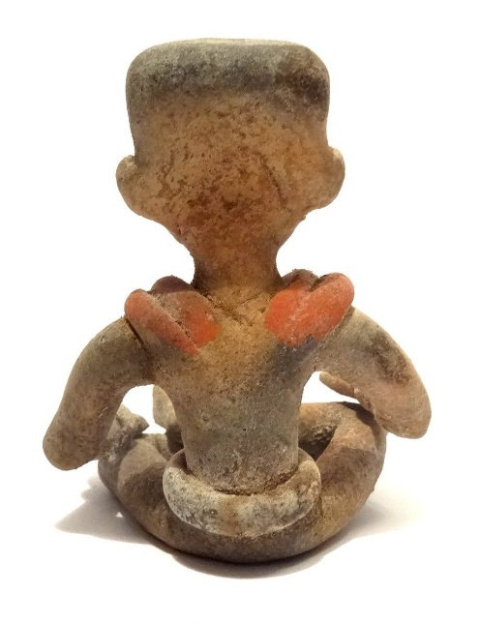

Figs. 1-8. Teotihuacan-Aztec-Terracotta-100-650 CE

**Case no.: 14**

**Accession Number:**

**Formal Label:** Teotihuacan-Aztec-Terracotta-100-650 CE displays the effects of a flattened skull denoting his élite status. The figure is wearing a bun around the waist perhaps as a ballgame participant as he wears special protectors on the tops of his feet, and he is also wearing a two-tiered red neck bun as well perhaps denoting a special status. The facial expression is especially well-modelled as though in anticipation of some event.

**Display Description:** Teotihuacan-Aztec-Terracotta-100-650 CE

**Teotihuacan flourished from 100 BCE-600 CE when it sustained a population of 125,000 and covered 21 km2 as the largest city in the Basin of Mexico with an influence extending into the Yucatan and the American southwest. However, it collapsed due to 30-50 percent precipitation reductions that coincided with abrupt decrease in agricultural production and urban population within a 100 year period, 700-800 CE, which was due to an abrupt mega-drought (Lachinet et al. 2012, Lachunet and Bernal 2017) that accentuated internal and violent social frictions punctuated by regional deforestation, soil erosion and urban abandonment.**

**This male figurine with hands on his upper thighs may indicate the readiness to participate in a ceremony. His facial expression captures his concern as he prepares himself for action.**

**LC Classification:**  [F1219.1.T2](http://josiah.brown.edu/search~S7?/cF1219.1.T27+M38+2009/cf++1219.1+t27+m38+2009/-3,-1,,E/browse)

**Date or Time Horizon:** 100-650 CE

**Geographical Area:** Teotihuacan

**Map:**

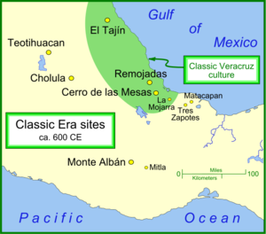

**Map of the valley of Mexico. After** [**https://en.wikipedia.org/wiki/File:Classic_sites_1.png**](https://en.wikipedia.org/wiki/File:Classic_sites_1.png)

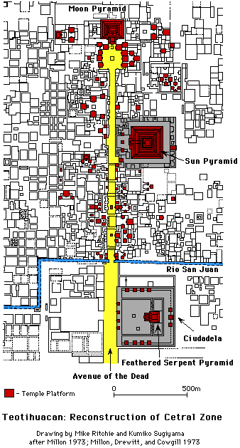

A recreation of a map of the city featured in the June 1967 issue of Scientific American and the captioned source. After https://upload.wikimedia.org/wikipedia/commons/1/14/Teotihucan_layout.gif

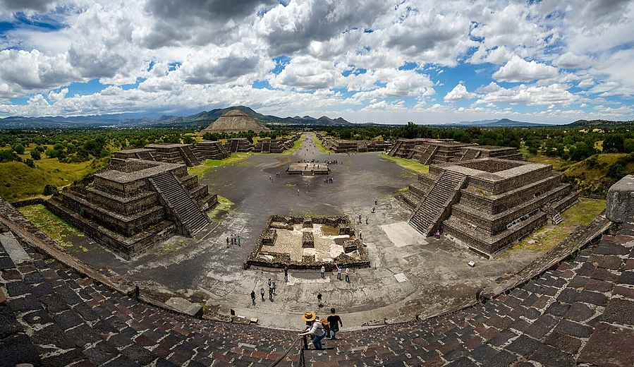

Panoramic view from the summit of the [Pyramid of the Moon](https://en.wikipedia.org/wiki/Pyramid_of_the_Moon), with the [Pyramid of the Sun](https://en.wikipedia.org/wiki/Pyramid_of_the_Sun) on the far left. ASfter Rene Trohs, 20 October 2016.

**GPS coordinates:** [19° 41′ 33″ N, 98° 50′ 37.68″ W](https://tools.wmflabs.org/geohack/geohack.php?pagename=File:Panoramic_view_of_Teotihuacan.jpg&params=019.692500_N_-098.843800_E_globe:Earth_type:camera_&language=en)

**Cultural Affiliation:** Aztec

**Media:** Terrracotta, red and white slip.

**Dimensions:** H 7,3 cm - W 6,2 cm

**Weight:**

**Condition: original**

**Provenance:**

ARCHEOLOGIA

Nathalie Renaud

62 route d'assevent

59131 Rousies, Nord-Pas-de-Calais

France métropolitaine

Phone:33(0)689407111

Email:archeologia@orange.f

**Discussion:**

The early history of Teotihuacan is quite mysterious and the origin of its founders is uncertain. Around 300 BC, people of the central and southeastern area of Mesoamerica began to gather into larger settlements.[[11]](https://en.wikipedia.org/wiki/Teotihuacan#cite_note-:0-11) Teotihuacan was the largest urban center of Mesoamerica before the Aztecs, almost 1000 years prior to their epoch.[[11]](https://en.wikipedia.org/wiki/Teotihuacan#cite_note-:0-11) The city was already in ruins by the time of the Aztecs. For many years, archaeologists believed it was built by the [Toltec](https://en.wikipedia.org/wiki/Toltec). This belief was based on colonial period texts, such as the [Florentine Codex](https://en.wikipedia.org/wiki/Florentine_Codex), which attributed the site to the Toltecs. However, the Nahuatl word "Toltec" generally means "craftsman of the highest level" and may not always refer to the Toltec civilization centered at [Tula, Hidalgo](https://en.wikipedia.org/wiki/Tula,_Hidalgo). Since Toltec civilization flourished centuries after Teotihuacan, the people could not have been the city's founders.

In the Late Formative era, a number of urban centers arose in central Mexico. The most prominent of these appears to have been [Cuicuilco](https://en.wikipedia.org/wiki/Cuicuilco), on the southern shore of [Lake Texcoco](https://en.wikipedia.org/wiki/Lake_Texcoco). Scholars have speculated that the eruption of the [Xitle](https://en.wikipedia.org/wiki/Xitle) volcano may have prompted a mass emigration out of the central valley and into the Teotihuacan valley. These settlers may have founded or accelerated the growth of Teotihuacan.[[*citation needed*](https://en.wikipedia.org/wiki/Wikipedia:Citation_needed)]

Other scholars have put forth the [Totonac](https://en.wikipedia.org/wiki/Totonac) people as the founders of Teotihuacan. There is evidence that at least some of the people living in Teotihuacan immigrated from those areas influenced by the Teotihuacano civilization, including the [Zapotec](https://en.wikipedia.org/wiki/Zapotec_civilization), [Mixtec](https://en.wikipedia.org/wiki/Mixtec), and [Maya](https://en.wikipedia.org/wiki/Maya_civilization) peoples. The builders of Teotihuacan took advantage of the geography in the Basin of Mexico. From the swampy ground, they constructed raised beds, called chinampas, creating high agricultural productivity despite old methods of cultivation.[[11]](https://en.wikipedia.org/wiki/Teotihuacan#cite_note-:0-11) This allowed for the formation of channels, and subsequently canoe traffic, to transport food from farms around the city. The earliest buildings at Teotihuacan date to about 200 BC. The largest pyramid, the [Pyramid of the Sun](https://en.wikipedia.org/wiki/Pyramid_of_the_Sun), was completed by AD 100.[[12]](https://en.wikipedia.org/wiki/Teotihuacan#cite_note-12)

### Year 378: "Conquest" of Tikal

In January 378, while [Spearthrower Owl](https://en.wikipedia.org/wiki/Spearthrower_Owl) supposedly ruled in Teotihuacan, the warlord [Siyah K'ak'](https://en.wikipedia.org/wiki/Siyah_K%27ak%27) "conquered" [Tikal](https://en.wikipedia.org/wiki/Tikal), removing and replacing the Maya king, with support from [El Peru](https://en.wikipedia.org/wiki/El_Per%C3%BA_(Maya_site)) and [Naachtun](https://en.wikipedia.org/wiki/Naachtun), as recorded by Stela 31 at Tikal and other monuments in the Maya region.[[13]](https://en.wikipedia.org/wiki/Teotihuacan#cite_note-13)

In 378 a group of Teotihuacanos organized a coup d'etat in Tikal, Guatemala. This was not the Teotihuacan state; it was a group of the Feathered-Serpent people, thrown out from the city. The Feathered-Serpent Pyramid was burnt, all the sculptures were torn from the temple, and another platform was built to efface the facade ...[[14]](https://en.wikipedia.org/wiki/Teotihuacan#cite_note-14)

### Year 426: "Conquest" of Copán and Quiriguá

In 426, the [Copán](https://en.wikipedia.org/wiki/Cop%C3%A1n) ruling dynasty was created with [K'inich Yax K'uk' Mo'](https://en.wikipedia.org/wiki/K%27inich_Yax_K%27uk%27_Mo%27) as their first king. The Dynasty goes on to have sixteen rulers.[[15]](https://en.wikipedia.org/wiki/Teotihuacan#cite_note-15) Copán is located in modern-day Honduras, as described by [Copán Altar Q](https://en.wikipedia.org/wiki/Cop%C3%A1n_Altar_Q).[[16]](https://en.wikipedia.org/wiki/Teotihuacan#cite_note-16) Soon thereafter, Yax K'uk' Mo' installs [Tok Casper](https://en.wikipedia.org/wiki/Tok_Casper) as king of [Quiriguá](https://en.wikipedia.org/wiki/Quirigu%C3%A1), about 50 km north of Copán.

### Zenith

The city reached its peak in 450 CE, when it was the center of a powerful culture whose influence extended through much of the Mesoamerican region. At its peak, the city covered over 30 km² (over ​11 1⁄2 square miles), and perhaps housed a population of 150,000 people, with one estimate reaching as high as 250,000.[[17]](https://en.wikipedia.org/wiki/Teotihuacan#cite_note-17) Various districts in the city housed people from across the Teotihuacano region of influence, which spread south as far as [Guatemala](https://en.wikipedia.org/wiki/Guatemala). Notably absent from the city are fortifications and military structures.

**References:**

Lachniet, Matthew S., Juan Pablo Bernal, Yemane Asmerom, Victor Polyak3, and Dolores Piperno A. 2012. “2400 yr Mesoamerican rainfall reconstruction links climate and cultural change,” *Geology* 40: 259-262.

Lachniet, Matthew S., Juan Pablo Bernal. 2017. AD 550-600 Collapse at Teotihuaan: Testing Climatic Forcing from a 400-Year Mesoamerican Rainfall Reconstruction.” In Harvey Weiss, *Megadrought and Collapse: From Erly Agriculture to Angkor*. New York: Oxford University Press, 183-204.

**Appendix: AP .3**